Light bites
served until 4pm

Sandwiches on white or granary bread with a salad garnish & tortillas
choice of filling: -

Ham & Cheese £5.45
Ham & Mustard £5.45
Cheese & Onion (v) £4.95
Tuna mayonnaise £5.45
Fish Fingers £4.95

Large jacket potato served with a salad garnish and a choice of filling: -
Welsh cheddar, (v) ￡5.45
Beans, (v) ￡5.45
Tuna Mayonnaise, ￡5.95

Starters

Soup of the day (v) ￡4.45
Freshly prepared soup of the day served with a fresh bread & butter

Spicy nachos (v)
Warm nachos topped with guacamole, salsa, jalapeños and welsh cheddar.
Small ￡3.95 serves 1
Large ￡4.95 serves 2-3

Chicken Bites with a salad garnish & chili dip ￡4.95

Halloumi Fries served with a salad garnish & chili dip £4.95

Tear & share Garlic Bread (v) ￡4.95 serves 1-2
add 80p for welsh cheddar

Mains

Fish and chips ￡11.95
Traditional beer battered cod with chips & mushy peas

Steak, Ale & Vegetable pie
Served with mash, mushy peas and gravy ￡12.95

Lasagne ￡9.95
Traditional beef lasagne served with a salad garnish and a sliced toasted baguette.

Grilled Butterflied Chicken breast ￡10.95
Served with chips, garden peas and gravy

Lamb shank served with mash potatoes in a minted gravy sauce £12.45

Pasta with a Herb tomato sauce topped with cheese and a sliced toasted baguette ￡9.95 (v) (vegan cheese available upon request)

Beef Madras Curry served with Chips or Boiled rice & Flatbread £10.95

Vegetable Madras Curry served with chips or boiled rice £9.95 (vegan friendly)

On the Grill

Steak options
All our steaks are 10oz in weight
All are served with roasted red onions, tomato, onion rings & Chips

10oz Rump Steak £13.95
10oz Sirloin Steak £15.95
10oz Rib-eye Steak £17.95
10oz Fillet £21.95
Add peppercorn sauce for an additional £2.50

10oz Gammon Steak served with chips, garden peas & egg or pineapple ￡10.95

Burgers

6oz Beef burger ￡9.95
Doubled up 6oz Beef burger ￡11.45
Chicken burger £10.95
Perl Las Blue Cheese Burger £12.45
Veggie Burger £9.95 (v)
All burgers are served with chips, small salad garnish & onion rings
Add welsh cheddar cheese for and additional 80p

Sides

Chips ￡2.95 (v)
Cheesy chips ￡3.50 v)
Boiled Rice ￡2.50 (v)
Mash potatoes ￡2.50 (v)
Side salad ￡3.50 (v)
Onion rings ￡2.95 (v)

Children’s Menu

All ￡4.95
All served with chips and a choice of peas or beans *

Chicken bites *
Sausages*
Fish fingers *
Tomato & Herb Pasta (Vegan cheese available on request)

Desserts

Gluten Free Chocolate Fudge cake & vanilla ice cream (v) ￡5.95
Gluten Free Baked NY Cheesecake & chocolate ice cream (v) £5.95
Sticky Toffee pudding & vanilla ice cream (v) ￡4.95
Selection of ice cream (3 scoops) (v) ￡4.45
Ice cream Sundae (v) £4.95

Children's selection of ice cream in a bowl (v)￡1.95

Food allergies and intolerances‐
Please speak to our staff about the ingredients in your meal when making your order.

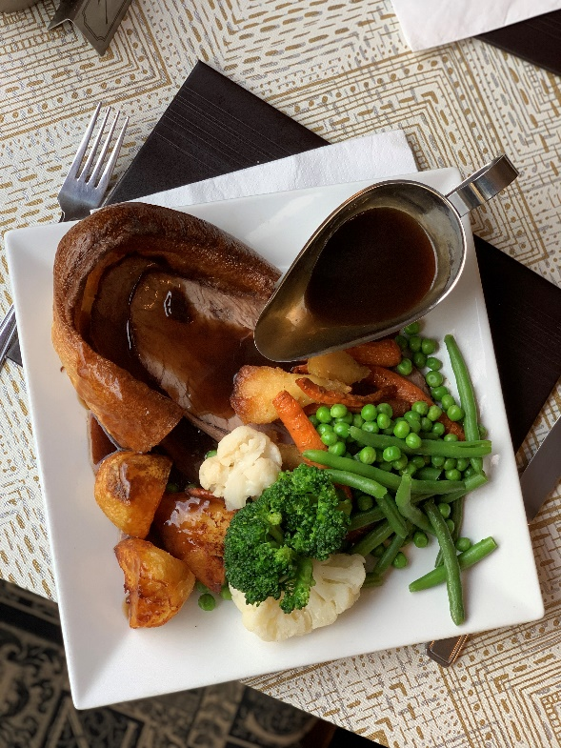
Roast Dinner

Every Sunday we served a
Traditional Sunday roast with a choice of meats,
Served with roasted root vegetables, spring vegetables, mash potatoes,
Yorkshire pudding & gravy

Adult portion £9 / kids portion £5.50

Available Midday until there gone

